Geospatial Analysis.

Nomcebo Ndlovu

**Task one: Kuils River Clinics on Public Health in Cape Town.**

**Introduction.**

Throughout history, the Western Cape has consistently been recognized as one of the regions in the nation that receives elevated levels of funding, leading to generally superior health outcomes in comparison to the majority of other provinces. Kuils River Clinics play a crucial role as healthcare facilities in Cape Town, providing a diverse array of services encompassing child, women, and men's health care, general TB, HIV, and STI care, as well as assistance for substance abuse. The emphasis of the clinics on child healthcare involves administering vaccinations, conducting well-baby check-ups, and offering nutritional guidance to foster optimal growth and development.

The presence of more clinics translates to a broader spectrum of healthcare services that can be provided, spanning from preventive care and treatments for various illnesses to maternal and child health services, along with specialized medical attention. The presence of a greater number of clinics within a specific area may imply a heightened level of resource allocation directed towards healthcare services. This allocation of resources is often influenced by the population density of the area in question. Urban locales, characterized by higher population concentrations, typically exhibit a larger number of healthcare facilities. In contrast, rural regions may have a lesser number of healthcare facilities, albeit supplemented by mobile clinics or outreach programs to cater to the healthcare needs of dispersed populations

**The Study Area.**

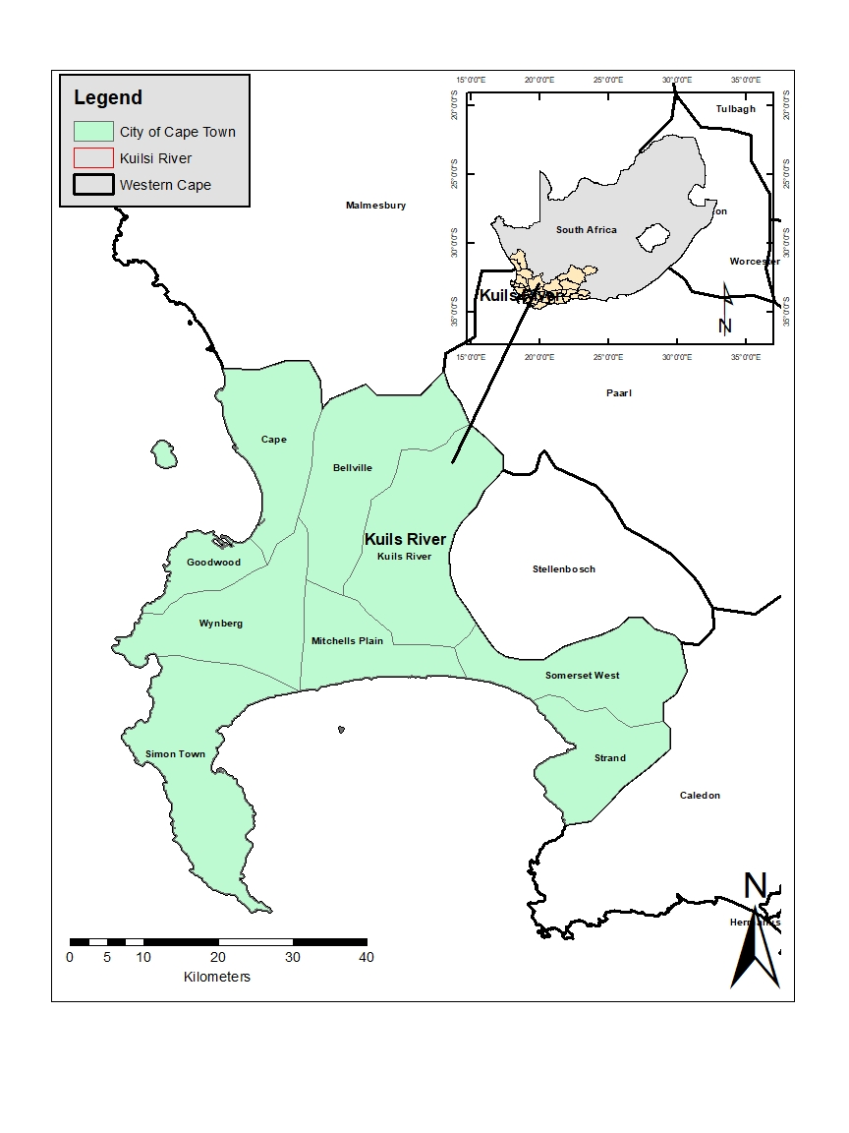

**Figure 1: Kuils River District in the City of Cape Town.**

**Methodology**

**Data Collection.**

This study integrates environmental data obtained from Sentinel-2 Copernicus ESA satellite imagery with social and urban data sourced from the Cape Town Data Portal (Fig3). The Copernicus initiative, part of the European Union's Earth monitoring initiative, coordinates the ESA Sentinel missions. The objective is to conduct a comprehensive analysis of urban areas in Cape Town, focusing on the relationship between environmental factors, social indicators, and urban development.

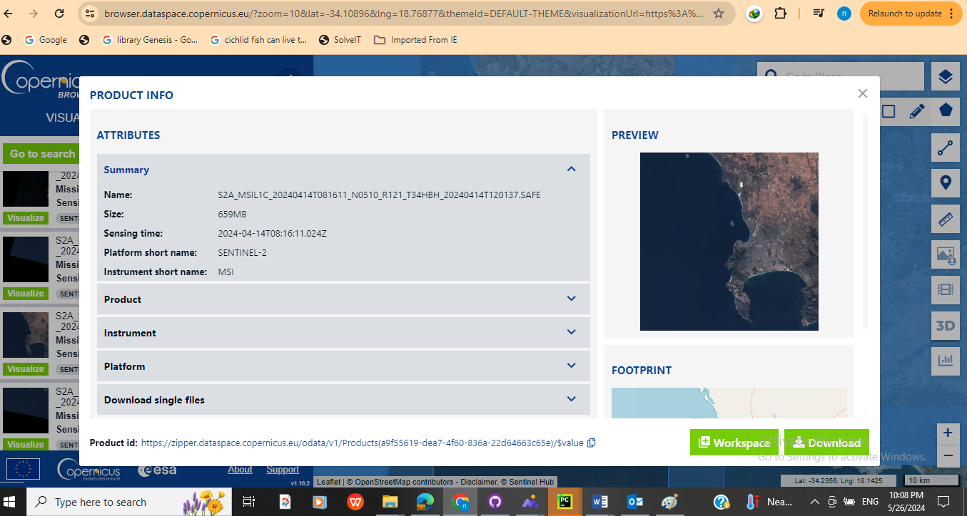

**Figure 2: Environmental Data (Sentinel-2 Copernicus ESA).**

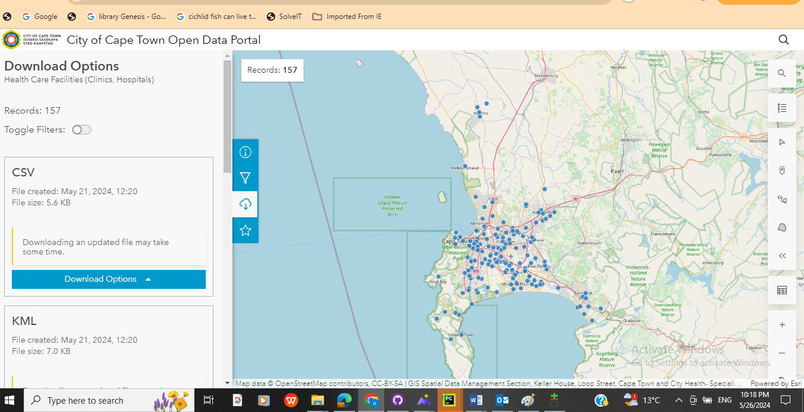

**Figure 3: Social and Urban Data (Cape Town Data Portal)**

**Data Processing**

Image pre-processing for atmospheric correction, radiometric calibration, and cloud masking involves applying algorithms and techniques to remote sensing images to improve their quality, accuracy, and suitability for analysis and interpretation. These pre-processing steps are crucial in ensuring that the remote sensing data is reliable and usable for various applications in geospatial analysis, environmental monitoring, and resource management.

**Atmospheric Correction**: This step involves correcting the effects of the Earth's atmosphere on remote sensing images. The atmosphere can cause distortions in the captured data, such as haze or scattering of light, which can affect the accuracy of the imagery. Atmospheric correction algorithms are applied to remove or reduce these atmospheric effects, allowing for more accurate interpretation and analysis of the remote sensing data.

**Radiometric Calibration**: Radiometric calibration is the process of converting digital numbers (DN) in a remote sensing image to absolute physical units, such as radiance or reflectance. This calibration ensures that the pixel values in the image represent meaningful physical quantities, allowing for quantitative analysis and comparison between different images or datasets.

**Cloud Masking**: Cloud masking involves identifying and removing or flagging pixels in the image that are affected by clouds. Clouds can obscure the underlying features of interest in the image and can interfere with analysis tasks. By masking out cloud-affected pixels, the image can be processed and analysed more effectively, especially for applications like land cover classification or change detection.

**Spatial Analysis**

The spatial analysis was conducted using a supervised image classification and land cover mapping. This involved the utilization of specialized remote sensing software, ArcGIS. In the context of supervised image classification, the analysis entailed the training and application of algorithms to categorize pixels within the remote sensing imagery into predefined classes or categories. Additionally, land cover mapping was undertaken to delineate and characterize different land cover classes, such as forests, water bodies, agricultural areas, urban zones, and other relevant land use categories. Through spatial analysis techniques within ArcGIS, the spatial distribution and extent of these land cover types were accurately mapped and represented spatially.

**Results**

**Environmental Analysis.**

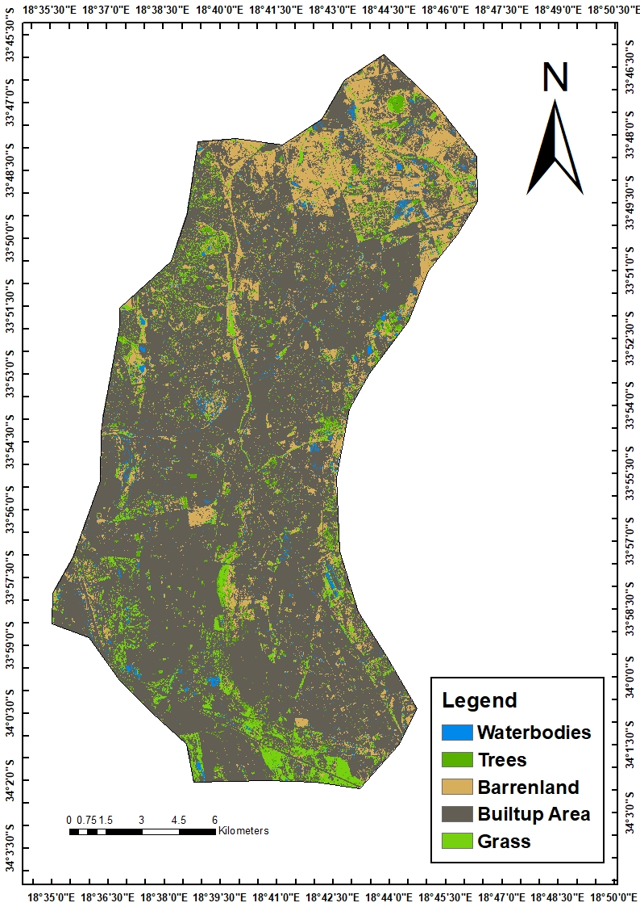

In the context of the Kuils River area in the Western Cape of South Africa, a notable shift in land utilization occurred during the two distinct periods under observation. Despite these alterations, the total land area available remained consistent, with minimal impact on beach areas. The key transformation involved the conversion of barren spaces into developed zones, agricultural territories, and vegetated areas. This indicates the utilization of previously unused land for the construction of infrastructure, facilitation of residential expansion, and establishment of agricultural plots for crop production. Some of these barren areas underwent natural reclamation by vegetation. The data presented in the figure indicates a significant period of construction activities in the Kuils River area, likely instigated by the rapid urban expansion characteristic of burgeoning urban settlements. The shift in land use exemplifies the dynamic progression of urban development and the challenges associated with accommodating a growing population in the area.

**Social and Urban Analysis of Kuils River, Western Cape**

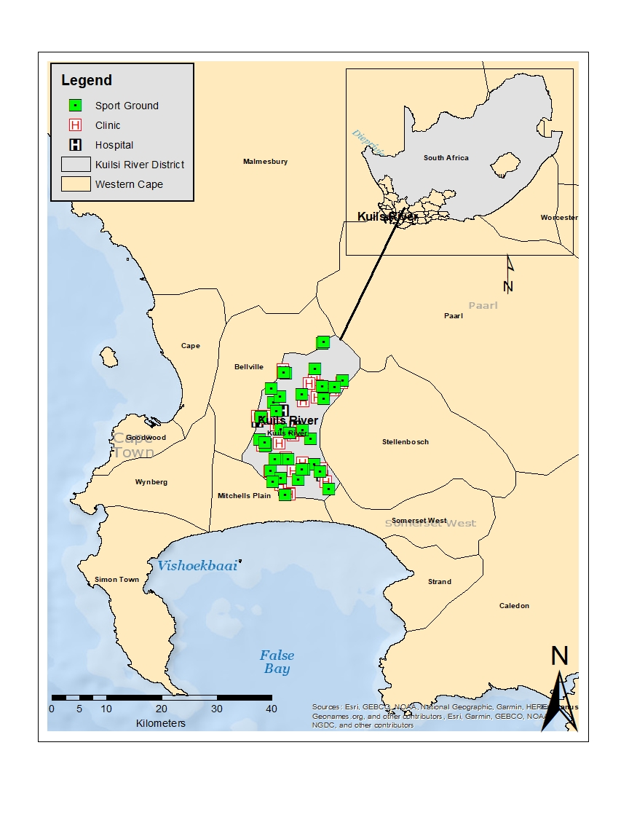

The socio-economic state of Kuils River in the Western Cape is notably reflected in the distribution and availability of key public amenities such as hospitals, clinics, and sports grounds. Using ArcGIS for spatial analysis, the mapping of these facilities highlights the area's robust healthcare and recreational infrastructure.

**Healthcare Facilities:**

The presence of multiple hospitals and clinics in Kuils River indicates a high level of investment in healthcare services. This abundance of medical facilities ensures that residents have accessible and comprehensive healthcare, contributing to better overall health outcomes. Such infrastructure is a testament to the Western Cape’s focus on improving public health and addressing medical needs promptly and effectively. The high concentration of healthcare facilities also suggests that the region allocates significant resources towards maintaining and enhancing its healthcare system, a crucial factor in supporting the well-being of its population.

**Recreational Facilities:**

Additionally, the availability of sports grounds within Kuils River signifies an investment in recreational and physical health amenities. These facilities provide residents with opportunities for physical activity, community engagement, and overall mental well-being. Access to recreational areas is an essential aspect of urban living that contributes to a higher quality of life.

**Conclusion**

The mapped data on hospitals, clinics, and sports grounds indicates that Kuils River benefits from better services compared to many other regions. This infrastructure reflects the socio-economic priorities of the Western Cape, which emphasizes comprehensive healthcare and recreational facilities as vital components of community development. Such investments are indicative of a relatively higher socio-economic status within the province, as they cater to the health, fitness, and recreational needs of the population.

This study emphasizes the significant importance of integrating diverse datasets for a thorough urban analysis. Through the amalgamation of remote sensing data and social as well as urban information, a nuanced comprehension of urban dynamics is attained, which is imperative for efficient planning and administration. The holistic approach not only showcases the current infrastructure and amenities but also identifies areas that require enhancements, thereby facilitating well-informed decision-making for the promotion of sustainable urban development. Particularly in the context of Cape Town, such a methodology proves to be invaluable, empowering stakeholders to tackle the distinct challenges of the city and capitalize on its advantages. The knowledge acquired through this study can steer forthcoming policies and investments, guaranteeing that urban development is fair and robust. As cities worldwide confront the challenges posed by rapid urbanization, the techniques and discoveries from this analysis can potentially serve as a blueprint for other urban regions aspiring towards sustainable expansion and an improved quality of life.